**LAPORAN PRAKTIKUM**

**ALGORITMA DAN PEMROGRAMAN**

**Pertemuan Ke-6**



**Disusun Oleh :**

|  |  |
| --- | --- |
| **NAMA** | **: NANANG SETYAWAN** |
| **NIM** | **: 185410025** |
| **JURUSAN** | **: Teknik Informatika** |
| **JENJANG** | **: S1** |

**STMIK AKAKOM**

**YOGYAKARTA**

**2018**

**LAPORAN PRAKTIKUM**

**ALGORITMA DAN PEMROGRAMAN**

**PERTEMUAN KE-6**

1. **PURPOSE**

* We can describe conditional execution
* we can describe logic operator
* we can make if construction

1. **LISTING**

**PRAKTIK 1**

1. Scenario

import java.util.Scanner;

public class Scholarship{

public static void main(String[]args){

Scanner sc= new Scanner(System.in);

System.out.println("Enter Your Grade?");

int nGrade= sc.nextInt();

System.out.println("Enter Your Absent?");

int nDaysAbsent= sc.nextInt();

if(nGrade>=88){

if(nDaysAbsent==0){

System.out.println("You quality for scholarship");

}

}

}

}

Output :

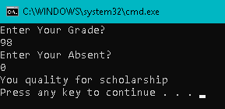

Explanation :

in this code we asked to use java.util.Scanner because we must input character from keyboard in the program output. This code use integer data type so we use sc.nextInt(); to input number or integer in output. In this codes, we faced 1 condition that the grade must bigger or same from 88 and the absent must be 0. so if we input the number or grade that bigger than 88 and its absent is 0, the output will showed (“you qualify for scholarship”). But if the grade under 88 or the absent is except 0, there is no output and the program will close if we press any number.

**PRAKTIK 2**

1. Using logical &&

import java.util.Scanner;

public class Scholarship1{

public static void main(String[]args){

Scanner sc= new Scanner(System.in);

System.out.println("Enter Your Grade?");

int nGrade= sc.nextInt();

System.out.println("Enter Your Absent?");

int nDaysAbsent= sc.nextInt();

if(nGrade>=88 && nDaysAbsent==0){

System.out.println("You quality for scholarship");

}

else{

System.out.println("You do not qualify for scholarship");

}

}

}

Output :

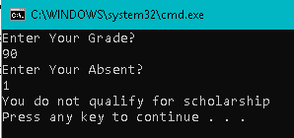

Explanation :

in this code, just same with first code. We asked to use java.util.Scanner to input from keyboard. The differences is, at the first code we use only one condition. That mean if the condition is true, the output will showed and if the condition is false, there is not output will be shown.

But in this code, if the first condition is true the output will be shown and also if the first condition false, the other output will be shown.

According to codes above, if grade bigger or same with 88 and absent is 0, the output will be show (“you qualify for scholarship”) but if one of that two statement is false or all false the output will be show (“you do not qualify for scholarship”).

1. Logical operator “Or”

import java.util.Scanner;

public class Scholarship2{

public static void main(String[]args){

Scanner sc= new Scanner(System.in);

System.out.println("Enter Your Grade?");

int nGrade= sc.nextInt();

System.out.println("Enter Your Absent?");

int nDaysAbsent= sc.nextInt();

if(nGrade>=88 || nDaysAbsent==0){

System.out.println("You quality for scholarship");

}

else{

System.out.println("You do not qualify for scholarship");

}

}

}

Output :

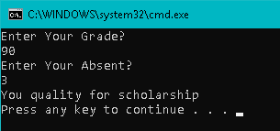

Explanation :

this code so similar or same from previous code or code above. Its same use java.util.Scanner, same use two condition with the two different output. The differences is, at previous codes we use && (AND) to combine first and second statement. But in this codes we use || (OR) to combine first and second statement (Grade and Absent). But the output is little different.

If first two statement is true or there is one true the output is (“you qualify for scholarship”) and the second output will show (“you do not qualify for scholarship”) if the two statement is all false.

1. Logical operator “Not”

public class NotOperator{

public static void main(String[]args){

int numberDaysAbsent= 2;

int grade= 65;

boolean madeFreeTutor= grade >=88;

if(!madeFreeTutor && numberDaysAbsent<3){

System.out.println("You qualify for free tutoring help");

}

}

}

Output :

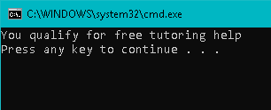

Explanation :

in this code we will use NOT operator that describe with (!). codes above didn’t use input keyboard or java.util.Scanner. We input the variable and its value in the code. We can see at code above. Grade = 65 and absent = 2. to get or to show output, we must see the output requirements. MadeFreeTutor is same with grade, it has 65 value. The requirement is if NOT (!) Made FreeTutor is bigger than 88 and absent must be smaller than 3. actually 65 is smaller than 85 but there is NOT (!) operator in MadeFreeTutor variable. So its true and the absent also true because it has smaller than 3 value and there is not NOT(!) operator. Because the statement all true the output must be (“you qualify for free tutoring help”).

**PRAKTIK 3**

1. Skipping the second AND test

public class ShortCircuitAnd{

public static void main(String[]args){

int x= 0;

int y= 2;

boolean b;

b= (x!=0) && ((y/x)>2); // mengapa tidak terjadi error di baris ini

System.out.println(b);

}

}

Output :

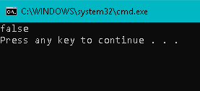

Explanation :

in this code we use logic operator to compare two statement and get the conclude. At codes above we can see x variable = 0 and y variable = 2. we will see the output, is that true or false.

First look at the requirement. B= x is not 0. this statement is false because the codes above show the value of x variable is 0.

go to second statement, y/z = 2/0 is not difiniton. So second statement is false.

Than according to logic operator AND, false && false = false. Thats why the output is false.

1. Short circuit Or

public class ShortCircuitOr{

public static void main(String[]args){

int x= 25;

boolean b= (x>=10) || (x<20);

System.out.println(b);

}

}

Output :

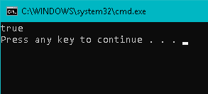

Explanation :

this codes is little similar from previous codes. The previous codes use AND (&&) logic operator but in this codes we will use OR (||) logic operator. Codes above has x variable with 25 value. So lets check the statement.

At first statement, is x bigger than 10 ? yes because 25 is bigger than 10. so the first statement is true.

Second statement, is x smaller than 20 ? not because 25 is bigger than 20. so the second statement is false. According to OR (||) logic operator, true OR false = true. Thats why the output is true.

**PRAKTIK 4**

1. Ternary scenario

public class TrackingGoal{

public static void main(String[]args){

int numberOfGoals= 5;

String s;

if(numberOfGoals == 1){

s= "goal";

}

else{

s= "goals";

}

System.out.println("I scored " + numberOfGoals + " "+s);

}

}

Output :

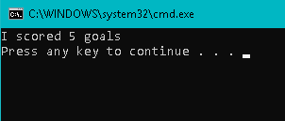

Explanation :

in this code we use if else method with two condition.

We can see at codes above it has numberOfGoals variable with 5 values. If requirement is, if numberOfGolas==1 the output will is (I scored 1 goals). But its false because numberOfGoals is 5. so the second condition is except the first condition. So it is true and the output is according to numberOfGoals variable. Thats why the output is (I scored 5 goals).

1. Ternary operator

public class TernaryOperator{

public static void main(String[]args){

int numberOfGoals= 1;

System.out.println("I score " +numberOfGoals+ " " +(numberOfGoals==1 ? "goal" : "goals"));

}

}

Output :

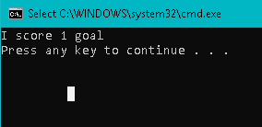

Explanation :

in this codes we didn’t use if else method or input keyboard method. We can see the numberOfGoals value is 1.

so lets see in the system.out.println. In this code is different from others because we use ternary method. So we show the output if the numberOfgoals==1. But if the numberOf Goals is 0, the output will be (“i score 0 goal”).

**PRAKTIK 5**

1. If construction

public class ChainingIf1{

public static void main(String[]args){

double income= 30000, tax;

if(income<=15000){

tax= 0;

}

else if(income<=25000){

tax= 0.05* income- 15000;

}

else{

tax= 0.05*(income-(25000-15000));

tax += 0.10*(income-25000);

}

System.out.println("Tax= "+tax);

}

}

Output :

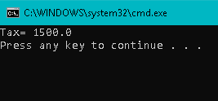

Explanation :

in this codes we use if else method with three conditions. We can see the income variable is 30000. we skipped first condition because its false. Its requirements is not fulfilled cause 30000 is bigger than 15000 and its requirements income must be smaller than 15000.

second condition also false because its requirements income must be smaller than 25000 which is the income is bigger than 25000.

third condition is except first and second statement. Because first and second condition is false so we get to third condition.

Tax = 0.05*(income-(25000-15000)) its mean 0.05*(30000-(25000-15000) = 1000

tax+= 0.10*(income-25000) its mean 0.10*(30000-25000)= 500

so 1000+500 = 1500. cause its boolean thats why the output is 1500.00.

1. Nested if construction

public class NestedIf{

public static void main(String[]args){

String tvType= "color";

int size= 16;

int discPercent= 0;

if(tvType.equals("color")){

if(size==14){

discPercent= 8;

}

else{

discPercent= 10;

}

}

System.out.println("discPercent= " +discPercent);

}

}

Output :

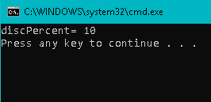

Expalantion :

this code using if else method with nested. Its mean in a statement there is a statement, or we can say there is if in if. We can see the variable above.

Tvtype= color, size= 16 and discPercent= 0.

the first condition requirement is if tvtype colored and if size ==14, discPercent is 8 but except this statement or else, discPercent is 10.

first statement didn’t fulfill this requirement because tv size must be 14, but in the codes above we know that tv size is 16. so we use second condition and the output is discPercent is 10.

**LATIHAN**

1. Watch movie

import java.util.Scanner;

public class Latihan1{

public static void main(String[]args){

int harga, rating;

Scanner sc= new Scanner(System.in);

System.out.print("Masukkan harga tiket: $");

harga= sc.nextInt();

System.out.print("Masukkan rating film: ");

rating= sc.nextInt();

if(harga>=12){

if(rating==5){

System.out.println("I'm interested in watching the movie");

}

}

else{

System.out.println("I am not interested in watching the movie");

}

}

}

Output :

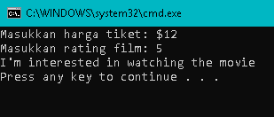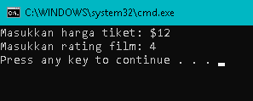

Explanation :

in this codes we faces again if and else method but with input keyboard or with java.util.Scanner. The requirements is if the price of ticket bigger than $12 and the film rating is 5, the output is (“i’m interested to watching the movie”). But else or if the requirements is not fulfilled the output is (“i’m not interested to watching the movie”).

But the second picture there is not output there. Yes because the first statement is fulfilled so the output of second condition didin’t show. But if the first statement is not fulfilled and the second statement is fulfilled, the output will be shown.

1. Odd and even

import java.util.Scanner;

public class Latihan2{

public static void main(String[]args){

int number;

Scanner sc= new Scanner(System.in);

System.out.print("Enter a number :");

number= sc.nextInt();

System.out.println((number%2==0 && number<=10)?"number is even":((number%2!=0 && number<=10)?"number is odd":"error index"));

}

}

Output :

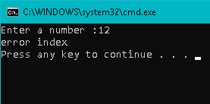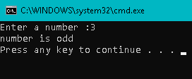

Explanation:

in this code we asked to using if else method. But its different with the method that always we use because in this case we will use if else method with ternary operator. In the ternary operator, true and false are divide with : symbols. It same if we write, if : else.

The requirements is the number under or smaller than 10 and complete if we divide by 2, the output is (“the number is even”). But if the number under 10 and didn’t complete if divide by 2, the output is(“the number is odd”). But if the number bigger than 10, the output is (“”error index)

1. Age and fare

import java.util.Scanner;

public class Latihan3{

public static void main(String[]args){

int age;

Scanner sc= new Scanner(System.in);

System.out.print("Enter Your Age: ");

age= sc.nextInt();

if(age<11){

System.out.println("your fare is $3");

}

else if((age>11) && (age<65)){

System.out.println("Your fare is $5");

}

else{

System.out.println("your fare is $8");

}

}

}

Output :

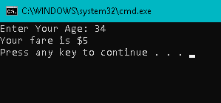

Explanation :

in this code, we will use if and else method again, but with 3 condition. First condition, second condition and except first and second condition. First condition is, if age under 11 the output is (“your fare is $3”). second condition is if age above 11 and under 65, the output is (“your fare is $5”). but the age except in the first and second condition, which mean the age above 65, the output is (“your fare is 8”). so this is according to us, what number wa want to input. Under 11 is first output, between 11 and 65 second output and above 65 third output.

**TUGAS**

1. Spp variable

import java.util.Scanner;

public class Tugas {

public static void main(String[]args){

double IPK;

int teori,praktik,praktikum,sppVar,tAkhir, tDiskon;

teori = 80000;

praktik = 120000;

praktikum = 150000;

System.out.println("Teori : Rp."+teori+"/sks | Praktik : Rp."+praktik+"/sks | Praktikum : Rp"+praktikum+"/sks");

Scanner input = new Scanner(System.in);

System.out.print("Masukkan jumlah sks Teori : ");

int sksTeori = input.nextInt();

System.out.print("Masukkan jumlah sks Praktik : ");

int sksPraktik = input.nextInt();

System.out.print("Masukkan jumlah sks praktikum : ");

int sksPraktikum = input.nextInt();

System.out.println("Jumlah sks teori anda :"+sksTeori+" *"+teori);

System.out.println("jumlah sks praktik anda : "+sksPraktik+" *"+praktik);

System.out.println("jumlah sks praktikum anda :"+sksPraktikum+" *"+praktikum);

sksTeori = sksTeori*teori;

sksPraktik = sksPraktik*praktik;

sksPraktikum = sksPraktikum*praktikum;

sppVar = sksTeori+sksPraktik+sksPraktikum;

System.out.println("Total Spp Variable :"+sppVar);

System.out.print("Masukkan IPK : ");

IPK = input.nextDouble();

if(IPK>=3.0){

System.out.print("Anda mendapat diskon 25% dari total spp Vairable");

System.out.println(" = (25*sppVariable)/100");

tDiskon = (sppVar*25)/100;

System.out.println("Total Diskon :"+tDiskon);

tAkhir= sppVar-tDiskon;

System.out.println("Total bayar :" +tAkhir);

}

else{

System.out.println("Anda tidak mendapatkan diskon");

System.out.println("Total Bayar :"+sppVar);

}

}

}

Output :

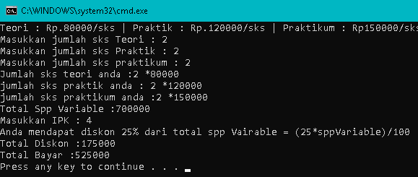

Explanation :

in this codes we asked to count total cost that we pay if we request teori courses, praktik courses and praktikum courses. And we will get discount if IPK 4.

so first we request per courses and multiply the courses price and total courses that we choose.

Then if we get the cost but our IPK is 4 so we get 25% discount. So for discount we multiply our cost with 25 and divide by 100. example, our first cost is 700000 and we get 25% discount. So 25*700000/100= 175000. so our discount is 175000. and now first cost – discount = 700000-175000= 525000. so total cost that we must pay is 525000.

1. IPK value

import java.util.Scanner;

public class TugasNilai{

public static void main(String[]args){

int nNIM, tugas, UTS, UAS, nakhir;

Scanner sc= new Scanner(System.in);

System.out.print("Masukkan NIM: ");

nNIM= sc.nextInt();

System.out.print("Masukkan Nilai tugas: ");

tugas= sc.nextInt();

System.out.print("Masukkan Nilai UTS: ");

UTS= sc.nextInt();

System.out.print("Masukkan Nilai UAS: ");

UAS= sc.nextInt();

nakhir= ((tugas*30/100)+(UTS*30/100)+(UAS*40/100));

System.out.println("Nilai akhir: "+nakhir);

if(nakhir>=80){

System.out.println("Nilai A");

}

else if(nakhir>=70 && nakhir<=79){

System.out.println("Nilai B");

}

else if(nakhir>=60 && nakhir<=69){

System.out.println("Nilai C");

}

else if(nakhir>=50 && nakhir<=59){

System.out.println("Nilai D");

}

else{

System.out.println("Nilai E");

}

}

}

Output :

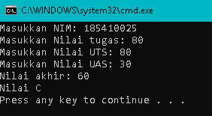

Explanation :

in this code we using if else method again. We asked to describe our grade by a alphabet.

The rules is we count grade 30% task, 30% UTS and 40% UAS. So the formula is (task*30/100)+(UTS*30/100)+(UAS*40/100). After we got the final grade we qualify the grade. Is it going to A,B,C,D or E. for the conditions, we got A if the grade is bigger than 80. we got B if the grade bigger than 70 and smaller than 79. we got C if the grade bigger than 60 and smaller than 69. and we got E if our grade bigger than 50 and smaller than 59.

**C) CONCLUTION**

In this practice , we know so many conditional execution, logic operator and if construction.

In this code we learn to campare many condition and statement with if and else method. Not just that, we also know statement in statement or if in if which is if the statement true continue to next statement. But if the first statement is false we can go to other conditions and dont need to continue to second statement if first statement false. And for logic operator we know so many symbol use to compare two statement. Even that OR, AND etc. so the main conclude is if we try little by little to learn we will know many things about program specially for java programs.